**Medical Fraud Detection – Project Plan  
Neel, Shagnik, Ishank, Prerit**

**Tool:**

1. Main –
   * Data Pre-processing – NAs, Outliers, Joining all 3 datasets – Shagnik, Ishank
2. Visualization Page – Neel, Prerit, Ishank
   * Data manipulation or metric creation – Neel, Prerit
   * Visualization wireframe – frontend integration – Neel, Prerit
   * Final dashboard – connections, filtering, buttons, navigation – Neel, Prerit, Ishank
3. Prediction Page –
   * Feature engineering – Based on models
   * Modelling-
     + Supervised (3 Models) – (1DL optional) – Ishank, Neel
     + Unsupervised (5 Models) – Shagnik
   * Finalize model Code -Shagnik
   * Frontend integration – Performance Metrics visualization - Shagnik
   * Fraud/ No Fraud Results

**Front-end:**

1. Home Page:
   1. Visualizations for all 3 datasets – KPIs, graphs, tables, interesting insights (%)
   2. Navigation to prediction page (What prediction??)
2. Prediction Page:
   1. Input data functionality
   2. Run prediction model
   3. Prediction results – Visualization, stats and functionality to download predicted data

**Wireframes:**  
  
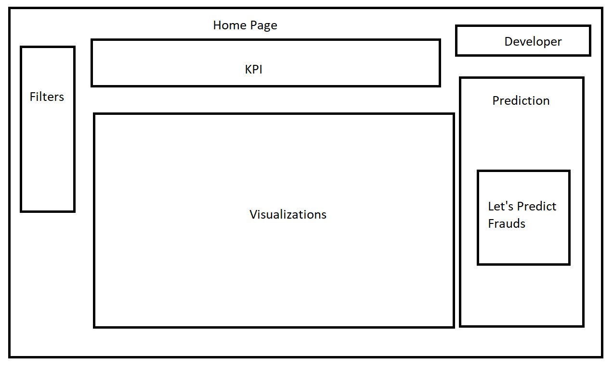  
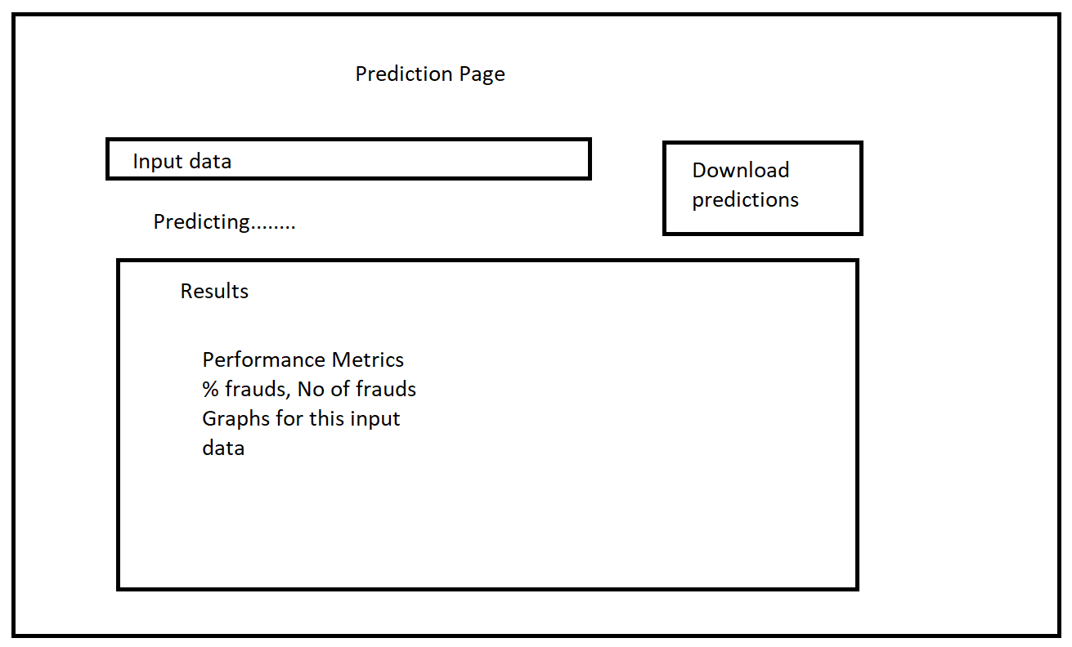

1. Data source
2. Data preprocessing
3. Website build (frame)
   1. Frontend
4. Contract frontend – backend
5. ML – front